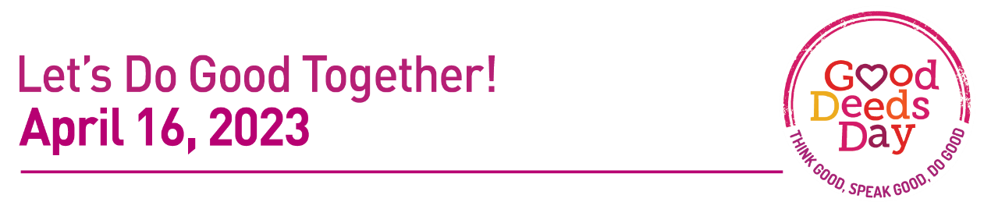

Press Release Template
[ORGANIZATION LOGO]
FOR IMMEDIATE RELEASE
April X, 2021
CONTACT: [YOUR NAME]
[PHONE, EMAIL]
MEDIA ADVISORY: [NAME OF ORGANIZATION]
Volunteers [DESCRIBE LOCAL PROJECT) as part of Good Deeds Day
[CITY, STATE]— [HUNDREDS] of [CITY] residents are expected to turn out on Good Deeds Day to do good for the benefit of others and the planet, putting into practice the simple idea that every single person can do a good deed, be it large or small, to improve the lives of others and positively impact the world.
Good Deeds Day is a global movement that unites 108 countries around the world in doing good deeds.
Since 2007, millions of people and thousands of organizations and businesses worldwide have united together every year to do good and volunteer, putting into practice the simple idea that every person can do a good deed, be it large or small, to improve the lives of others and positively impact the world.
Crossing all borders and cultures thousands of businesses and organizations, including MTV Global, ABC Network Studios NYC, NASDAQ, Pope Francis, and many more have taken part. For more information about Good Deeds Day visit: www.good-deeds-day.org

WHO: [Local dignitaries, national service participants, community volunteers, etc.]
WHAT: [Insert the name of the event or activity]
WHERE: [Insert address where the event will take place (NOT your office address)]
WHEN: [Insert the date and start and end times for the event]

